Princess Sumaya University for Technology
King Abdullah II Faculty of Engineering
Electrical Engineering Department

Embedded Systems Project

Autonomous Mobile Robots Challenge



Hajar Labib | 20220301 | IOT
Zaina Abedrabbo | 20220552 | Electronics
Mais M0hammad | 20221183 | NIS

June 21, 2026

Abstract
This project presents the design of an autonomous robot capable of line following, tunnel navigation, wall following, and parking without human intervention. The robot was implemented using the PIC16F877A microcontroller with IR sensors, ultrasonic sensors, and an LDR sensor. Two DC motors on a 2WD chassis were used for movement. Functions such as PWM, ADC, timers, and interrupts were applied to control the robot and enable decision-making. Despite challenges including motor speed differences, sensor sensitivity, and power stability.

Table of Contents
Abstract 2
1. Introduction 5
1.1 Presenting the Project 5
1.2 Context 5
2. Mechanical Design 5
2.1 WD Robot Kit design 5
2.2 Battery linkage 6
2.3 Sensor Location 6
3. Electrical design 6
3.2 Buck Converter 7
3.3 Pin Assignment 9
3.4 Hardware schematic 11
3.5 Sensor Subsystem 11
3.5.1 Flow Sensors for Lines 11
3.5.2 Sensor for Light Detection 12
3.6 Output devices ( Buzzer , Flag mechanism) 12
4. Software Design 13
4.1 State Flow chart 13
4.2 Handling Each Zone 14
4.2.1 Start Zone 14
4.2.2 Line Following Zone 14
4.2.3 Tunnel Area 15
4.2.4 Bump Zone 15
4.2.5Parking Zone 15
5. Problems And Recommendations 16
6. Conclusion 16
7. Reference 16

Table 1 8
Table 2 8
Table 3 8
Table 4 9
Table 5 9
Figure 1 6
Figure 2 12

1. Introduction

1.1 Presenting the Project
Autonomous mobile robots are systems that operate independently using sensors to detect and respond to environmental obstacles. A microcontroller acts as the main control unit by processing sensor data, controlling motors, and executing programmed algorithms. In this project, the PIC16F877A microcontroller was selected due to its suitable integrated peripherals and efficient performance.
The aim of this project was to design and implement an autonomous mobile robot capable of completing several tasks, including line following, tunnel navigation, and parking. The project demonstrates practical applications of embedded systems through the integration of mechanical components, electronic circuits, and software programming.

1.2 Context
The autonomous robot was required to navigate a predefined track and successfully complete different tasks using feedback control techniques. Sensors were used to collect environmental data, which was then processed by the microcontroller to generate appropriate responses.
Infrared (IR) sensors were used for line detection by emitting infrared light and measuring the reflected signal to distinguish between black and white surfaces. Ultrasonic sensors were also used for object detection and distance measurement. These sensors operate by transmitting high-frequency sound waves and measuring the reflected echo to determine the distance between the robot and surrounding objects.

2. Mechanical Design

2.1 WD Robot Kit design
The robot was designed using a 2WD kit following the steps: (provided in the YouTube video attached in the references below)
1)Connect the swivel wheel using screws and nuts at the bottom of the chassis
2)Solder two wire onto each of the DC motors place on each side of the top of chassis
3)Insert the switch between the two motors as well as the battery holder using screws and nuts
4)Connect the H-bridge and the buck converter in the same way
5)Attach the wheels onto the DC motors

2.2 Battery linkage
The battery was attached to the switch by soldering the red wire to one terminal of the switch and connecting an external wire to the other terminal of the switch (reserved for connecting to H-bridge) while the black wire of the battery is set aside for now since it will be needed for the H-bridge connection. In this manner, when the switch is activated, the voltage travels through the wires but does not yet energize the motors because the circuit remains incomplete; we must employ an H-bridge to finalize the connection and supply power to the motors for speed and direction control. The switch functions as an open circuit when turned off and a closed circuit when on, determining when we allow the power to flow through the circuit.
2.3 Sensor Location
In our robot design, we incorporated 2 IR sensors, 2 ultrasonic sensors, and one LDR, which were positioned appropriately at the front of the chassis board.
The remaining two IR sensors were positioned a bit to the left and right, secured with double-sided tape, although their locations were adjusted based on testing and experimentation with the width of the line-following track.
LDR positioned over the IR sensor
Two ultrasonic sensors are mounted on the front of the chassis, one located centrally and the other on the right.

3. Electrical design
The robots motor drive system consists of two DC motors on either side of the chassis that operate from a power supply (battery) and are controlled using the H- Bridge as a motor driver circuit to interface low current signals with high current DC motors and protect PIC from motor loads. Figure 1 is a labelled image of the L298N H-bridge we will be using for this project.
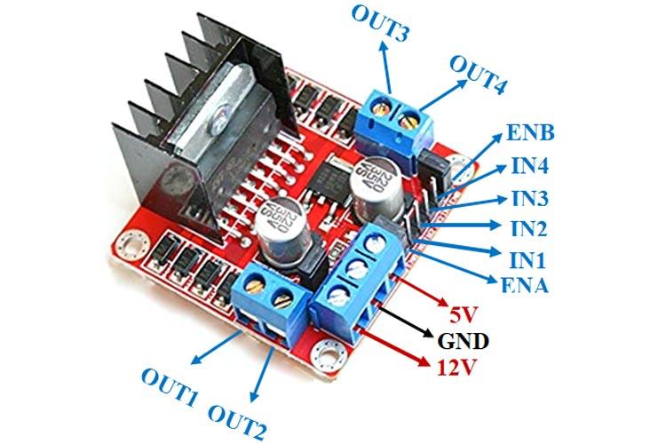
Figure 1
IN1 and IN2 control the direction of the motor connected to OUT1 and OUT2 (left motor) while IN3 and IN4 control the direction of the motor connected to OUT3 and OUT4 (right motor)
ENA and ENB are used to control the speed of the motors using pulse width modulation
The H- bridge is connected as follows:
- Connect OUT1 and OUT2 to one motor (left motor) red and black wires and OUT3 and OUT4 to the other motors wires (right motor).
- Connect external wire from switch to 12V on H-bridge
- Connect black wire from the battery to ground on H-bridge then to common ground on our breadboard
- Connect the following to the corresponding PIC pins
  - IN1 to RD0(pin 19)
  - IN2 to RD1 (pin 20)
  - IN3 to RD2 (pin 21)
  - IN4 to RD3 (pin 22)
  - ENA to RC2 (pin 16)
  - ENB to RC1 (pin 17)

3.2 Buck Converter
For voltage regulation we used a buck converter to step down the higher input voltage of 12V coming from the battery to a lower output voltage of 5V for the PIC since 12V cannot be applied directly to the microcontroller as this value could permanently damage it and other low voltage components. The voltage 5V was chosen from the recommended operating voltage of PIC16F877A taken form the data sheet and the buck converter was chosen due to its high efficiency and low heat dissipation and it provides microcontroller and components with stable voltage.
The buck converter was then connected as follows
- IN+ à taken from 12V of H-bridge
- IN- à negative input voltage connected to ground of H-bridge
- OUT+ à VDD on the PIC (pin 32)
- OUT- à VSS on the PIC (pin 31)
-Direction Control test
To test the direction of the robot, the outputs IN1-4 are changed accordingly:
-To make robot move forward:
- IN1=1 IN2=0 (left motor moves forward)
- IN3=1 IN4=0 (right motor moves forward)
-To make robot turn right:
- IN1=1 IN2=0 (left motor moves forward)
- IN3=0 IN4=0 (right motor don’t moves)
-To make robot turn left:
- IN1=0 IN2=0 (left motor moves backwards)
- IN3=1 IN4=0 (right motor don’t moves )
- To make robot move backwards:
- IN1=0 IN2=1 (left motor moves backwards)
- IN3=0 IN4=1 (right motor moves backwards)
However, after testing it was seen that the robot direction was reversed so we changed the direction definition by switching IN1 and IN2 as follows:
-Forward motion:
- IN1=0 IN2=1 (left motor moves forward)
- oIN3=0 IN4=1 (right motor moves forward)
We also saw that each motor speed was different; our right wheel was a bit slower than our left hence it seemed as though the car was turning rather than moving forward. This is fixed by changing the speed of the slow motor to a higher speed compared to the stronger motor.
-Speed Control test
Using the logic of turning left and right defined above worked, however the turns were extremely sharp hence instead of moving a wheel backwards this wheels speed was reduced using PWM to a lower speed than the forward wheel.
When turning, the wheel on the inside (inner wheel) must have a slower speed than the wheel on the outside (outer wheel). Additionally, for forward motion the wheel on right side was weaker than the left side hence by testing we were able to identify that the speeds of the motors differed by 10 PWM.
Pulse width modulation to control speed several speeds are tested and seen.
After testing the following the speeds for high speed, low speed and medium speed are chosen:

Duty | Speed | Use
Left motor: 0  Right motor: 0 | Stop | For park mode
Inner motor: 70  Outer motor: 80 | Medium | For turning
Left motor: 70  Right motor: 80 | Fast | Tunnel or straight path
Table 1

3.3 Pin Assignment
PORT A – Sensors & Buttons
PIC Pin | Port | Direction | Function
2 | RA0 | Input (ADC) | LDR Sensor
Table 2
PORT B – Ultrasonic Sensors

PIC Pin | Port | Direction | Function
34 | RB1 | Output | Font Ultrasonic ECHO
35 | RB2 | Input | Front Ultrasonic TRIG
40 | RB7 | Output | Right Ultrasonic ECHO
39 | RB6 | Input | Right Ultrasonic TRIG
Table 3

PORT C – Motors & Servo

PIC Pin | Port | Direction | Function
19 | RD0 | Output | H-Bridge IN1
20 | RD2 | Output | H-Bridge IN2
21 | RD3 | Output | H-Bridge IN3
22 | RD4 | Output | H-Bridge IN4
17 | RC1 | Output | H-Bridge ENA
16 | RC2 | Output | H-Bridge ENB
18 | RC3 | Output (PWM) | Servo Motor
Table 4
PORT D – LEDs, IR’s & Buzzer

PIC Pin | Port | Direction | Function
37 | RB5 | Input | IR Line Sensor - Left
36 | RB4 | Input | IR Line Sensor – Right
26 | RC7 | Output | Buzzer
Table 5

3.4 Hardware schematic
The following schematic describes how each component was wired and connected to PIC16F877A
This schematic was created using Proteus:
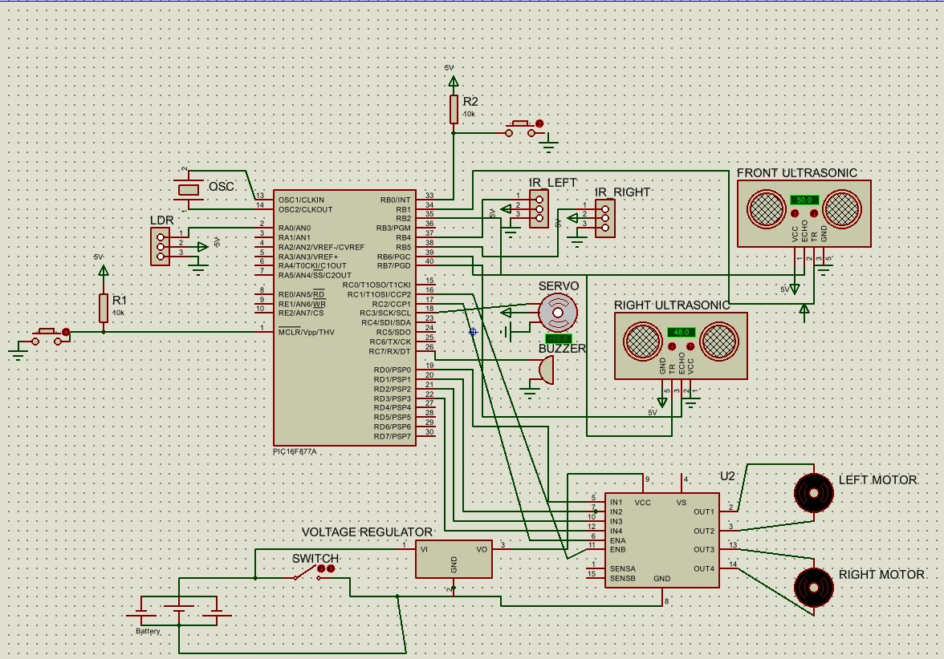

3.5 Sensor Subsystem
3.5.1 Flow Sensors for Lines
We employ two IR sensors for the line-following system (installing one on the left front of the robot and another on the right front).
Testing revealed that our IR sensors recognized black as logic 0 and white as logic 1, with sensitivity fine-tuned by adjusting the potentiometer with a screwdriver.
The logic employed in the subsequent line was as follows:
- If both right and left IR =0, move forward .
- If the right IR=0 and the left IR=1, then turn right.
- If right IR=1 and left IR=0 then turn left.
- If both IR's =1, make a left turn .

3.5.2 Sensor for Light Detection
An LDR (Light Dependent Resistor) sensor was used to detect changes in light intensity and enable the robot to switch to tunnel mode. When the light intensity increases, the resistance of the LDR decreases, allowing more current to flow and producing a higher voltage output, which is interpreted as logic 1. In low-light conditions, the resistance increases, reducing the current flow and producing a lower voltage output, resulting in logic 0.

3.6 Output devices ( Buzzer , Flag mechanism)
We connected a buzzer and programmed it so that it turns on when the LDR detects light intensity drop. Finally, we also connected servo motor that we require to turn 90 degrees and pull out the designed flag. The position of the shaft is controlled by the duty cycle of the PWM.

4. Software Design

4.1 State Flow chart
For the software design we created several zones and based on the robot’s readings of its surroundings it can transition between one zone and another. The following flowchart was used to determine the transition between each state.
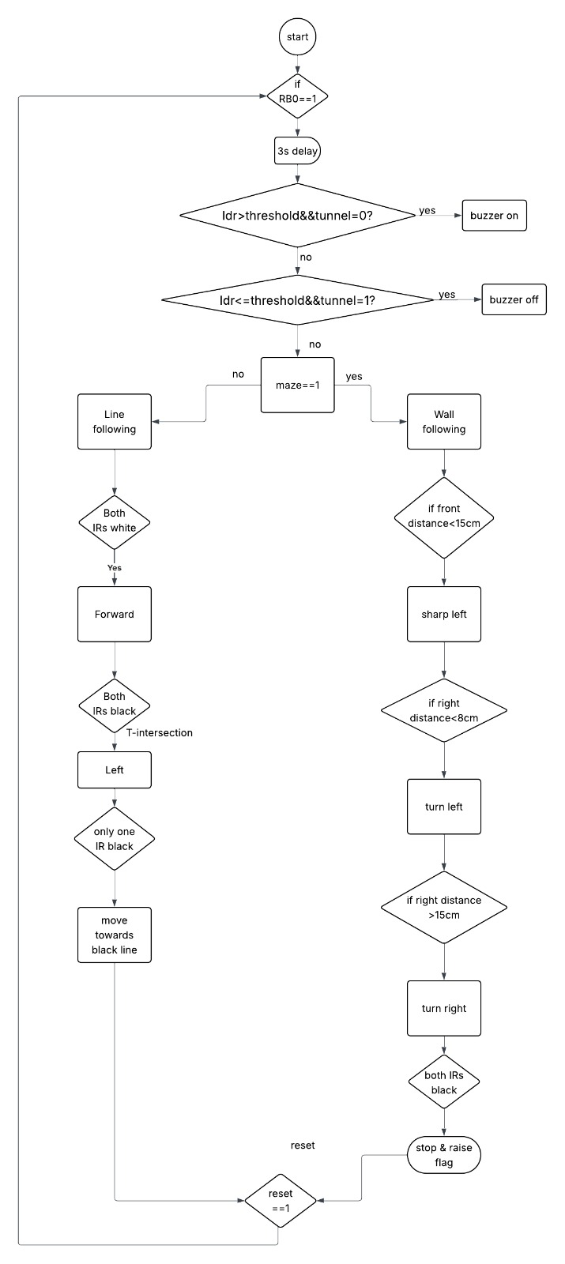
Figure 2

4.2 Handling Each Zone

4.2.1 Start Zone
- To create the 3 second start delay, we used msdelay(3000). Our Fosc = 8MHz so Finst = 8MHz/4 = 2MHz, meaning one instruction cycle takes 0.5µs. The function uses a nested loop where the inner loop runs 332 iterations burning approximately 1ms each time, and the outer loop repeats that 1ms exactly 3000 times, giving 3000 × 1ms = 3 seconds total. The intention was to wait for a button press on RB0 then delay 3 seconds before the robot starts moving, however this was commented out in the final code meaning the robot starts immediately on power on.

4.2.2 Line Following Zone
For line following we use PWM to control the speeds this works by controlling how long we want the voltage on or off and this ratio called the duty cycle determines the speed. We use timer 2 to generate the PWM timing:
- We create our function where we first set PR2=250 this value is chosen to ensure the frequency doesn’t create any audible noise.
- Next, we set T2CON = 0b00000111 this means that we turn on timer2 and use the prescaler 1:16
- Then we set CCP1CON = 0b00001100 & CCP2CON = 0b00001100 this means they are placed in PWM mode note CCP1 controls left motor while CCP2 controls right
- We set the speed by setting CCPRxL to the duty cycle needed the range of this duty cycle is from 0 to 250 where 250 gives the highest speed. The chosen values we chose are given in the speed control section of this report
Based on the logic of the IR sensors discussed the left and right motors speeds are changed accordingly and the following functions are used:
4.2.3 Tunnel Area
In the tunnel area, we utilized an analog to digital converter to transform the analog outputs from our LDR into digital values that are comprehensible.
ADC operates by transforming an analog voltage into a 10-bit digital value, which we utilize to determine whether the light is on or off, subsequently signaling the buzzer to activate or deactivate accordingly. This is how we configure our code:
- Setting ADCON1=0b10001110 indicates that the result is right justified and that the input at RA0 is in analog form.
- Then, we configure RA3, which is linked to the input LDR.
We then define a function that outputs a 10-bit ADC value, having set ADCON0 = 0b01000001, indicating that we chose ADC and selected channel AN0 = RA0, followed by a brief acquisition delay of 20 μs (according to the datasheet).
- Next, we assign GO_DONE_BIT=1 to initiate the ADC process; when cleared, the result (10 bits) is provided and saved in ADRESH and ADRESL.
In this manner, we managed to establish an ADC value that can be compared to our experimentally determined threshold value, allowing us to apply the subsequent logic:
- When the LDR value falls above the threshold, it indicates dark mode (within a tunnel) and the buzzer activates.
- If the LDR value is lower than the threshold, we are outside the tunnel and the buzzer is inactive.

4.2.4 Bump Zone
For the bump zone once one of the IR sensors detects black it goes back to line following and can successfully go over the bump smoothly

4.2.5Parking Zone
To indicate park zone both IR’s must detect black after it has completed bump then the robot must do the following:
- Move forward until certain threshold from the front of the wall is detected
- Then stop, turn off the motors and raise the flag.
The flag is controlled by a servo motor that turns 90 degrees and is controlled using PWM as follows:
- For a standard servo a 20ms PWM period is required and a high pulse width of 1ms
- The remaining 19ms of the pulse is completed at low time

5. Problems And Recommendations
A challenge we faced was making sure the motors operate at the same speed. Our right motor was significantly less powerful than our left, which caused it to halt entirely when set on the ground. To address this issue and offset this limitation by providing our right motor with 10+ additional PWM compared to our left. This value was determined by gradually raising the disparity between the right and left motor until proper forward movement was achieved.
We encountered a sensitivity issue with our IR sensors, which failed to detect accurately. This was addressed by positioning the robot with the appropriate code loaded so that the black line represents zero and the white line signifies one.
Modifying our code slightly or merging two zones would alter the robot's functionality, causing it to cease operating as before. At times, the sensors would cease to work, and other times it would be a problem with the code.

6. Conclusion
This project met its goal of creating an autonomous mobile robot that can navigate various environments through sensor-driven control and embedded decision-making. By combining mechanical design, electronic hardware, and real-time software on a PIC16F877A microcontroller, the robot effectively navigated through all the designated areas.
Following this project, we observe how straightforward embedded systems can exhibit autonomous actions akin to those utilized in actual robotic and automation settings. Utilizing our expertise from the embedded course and putting it into practice, we successfully developed a well-organized software design, and experimental testing validated its proper functioning under different conditions.

7. Reference
https://ww1.microchip.com/downloads/en/devicedoc/39582b.pdf

